**A113 – Mathematics**

**Worksheet for Problem 03: A Lost Civilisation**

**Mechanical Simulator**

1. Download **MechanicalSimulator.exe** from LEO and run it. From the symbols observed on the display screen, can you determine the number of marbles in the device? Why or why not?

No. It is because the marble acts as a constant.

1. Let us investigate the possible meaning(s) of the symbols on the device by considering how the symbols change when a marble is added or released.
   1. What do you observe on the display screen each time a marble is added?

The rightmost symbol will change.

* 1. Describe the sequence, on how the rightmost symbol changes when marbles are added continuously?

Once every four marbles, the left side changes to the next letter according to the table (V→A→M→W). For every marble that is added, the right side changes each time a marble is added according to the sequence of the table(V→A→M→W).

* 1. Which transition of the rightmost symbol will bring about a change to its adjacent symbol when a marble is added?

W→V.

* 1. What do you observe on the display screen each time a marble is released?

The letter is changed backwards according to the table(W→M→A→V).

* 1. Which transition of the rightmost symbol will bring about a change to its adjacent symbol when a marble is released?

V→A.

1. A stone tablet was found later at the excavation site. This tablet, as shown in Figure 1, was inscribed with symbols similar to those found on the mechanical device.

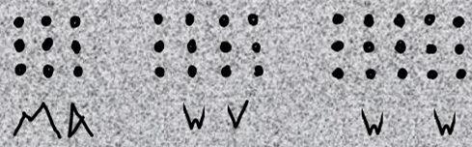

Figure 1

* 1. How many dots do you think these symbols “MA”, “WV” and “WW” represent?

MA = 9 WV = 12 WW = 15

* 1. Using **MechanicalSimulator.exe,** observe the transitions from “MA” to “MW”. Which symbol do you think represent a larger quantity, “A” or “W”? Explain your answer.

MW/W. With reference from Figure 1 and the Table given in the Mechanical Simulator, the sequence is arranged such that it is in an ascending order. Hence, since “A” comes into the order earlier, “W” will naturally be a larger outcome since it comes later in the order.

* 1. Keep adding marbles until you see “WW” on the **MechanicalSimulator.exe.** Verify that “VV” will come immediately after “WW” when one more marble is added.

This is true.

* 1. Which of the symbols “V”, “A”, “M”, and “W” is used to represent “nothing”? Explain your answer.

V. This is because V is a neutral vlue since the entire sequence restarts when W→V

1. From the observations, you have made so far, explain the relationships between the symbols “V”, “A”, “M”, “W”, the positions they occupy and the quantities they represent.

V→A→M→W

0→1→2→3

**Common Number Systems**

1. In the problem statement, four symbols (“V”, “A”, “M”, “W”) are used to represent quantities. This is known as a base 4 number system. The number system that we use every day is based on ten symbols (0, 1, 2, 3, 4, 5, 6, 7, 8, 9) and it is known as the decimal or base 10 number system. Other common number systems include octal (base 8) and hexadecimal (base 16) number systems. As an illustration, we can represent quantities from “nothing” to “fifteen” using the different number systems as follows:

|  |  |  |  |  |
| --- | --- | --- | --- | --- |
| Quantity | Decimal  (Base 10) | Binary  (Base 2) | Octal  (Base 8) | Hexadecimal  (Base 16) |
| Nothing | 0 | 02 | 08 | 016 |
| One | 1 | 12 | 18 | 116 |
| Two | 2 | 102 | 28 | 216 |
| Three | 3 | 112 | 38 | 316 |
| Four | 4 | 1002 | 48 | 416 |
| Five | 5 | 1012 | 58 | 516 |
| Six | 6 | 1102 | 68 | 616 |
| Seven | 7 | 1112 | 78 | 716 |
| Eight | 8 | 10002 | 108 | 816 |
| Nine | 9 | 10012 | 118 | 916 |
| Ten | 10 | 10102 | 128 | A16 |
| Eleven | 11 | 10112 | 138 | B16 |
| Twelve | 12 | 11002 | 148 | C16 |
| Thirteen | 13 | 11012 | 158 | D16 |
| Fourteen | 14 | 11102 | 168 | E16 |
| Fifteen | 15 | 11112 | 178 | F16 |

Note: All quantities will be in the Decimal number system, unless indicated otherwise.

**Conversion from other base system to decimal**

1. It is useful to learn how to convert quantities from other base systems to their decimal number form. For example, to convert 111012 from base 2 to base 10, we can do the following:

Step 1: Determine the positional value of each digit. This corresponds to increasing powers of the base of the number system, starting with 0 power from the rightmost position.

|  |  |  |  |  |  |
| --- | --- | --- | --- | --- | --- |
| Binary number (Base 2) | 1 | 1 | 1 | 0 | 1 |
| Positional value | 24 | 23 | 22 | 21 | 20 |

Step 2: Multiply the digits by the positional values in the corresponding columns and sum up the products. The obtained value is the equivalent decimal number.

|  |  |  |  |  |  |
| --- | --- | --- | --- | --- | --- |
| Binary number (Base 2) | 1 | 1 | 1 | 0 | 1 |
| Positional value | 24 | 23 | 22 | 21 | 20 |
| Decimal number (Base 10) | 1×24 + 1×23 + 1×22  + 0×21 + 1×20 | | | | |

Hence, 111012 = 1×24 + 1×23 + 1×22 + 0×21 + 1×20 = 29

1. Now, let us consider the octal (base 8) number system which uses eight symbols 0, 1, 2, 3, 4, 5, 6, 7 to represent quantities. Using similar steps from the above, convert 61238 from base 8 to base 10.

Hence, 61238 = 6×83 + 1×82 + 2×81 + 3×80 = 3155

1. Next, let us consider the hexadecimal (base 16) number system which uses sixteen symbols 0, 1, 2, 3, 4, 5, 6, 7, 8, 9, A, B, C, D, E, F to represent quantities. Using similar steps from the above, convert A3216 from base 16 to base 10.

Hence, A3216 = 162×10 + 161×3 + 160×2 = 2610

**Conversion from decimal to other base system**

1. Conversely, we can also convert quantities from decimal to other base systems. For example, to convert 29 from decimal (base 10) to binary (base 2), we can use the following long division method:

Step 1: Divide the decimal number to be converted by the value of the new base. Record the remainder and quotient as shown.

|  |  |  |
| --- | --- | --- |
|  |  | Remainder |
| 2 | 29 | 1 |
|  | 14 |  |

Step 2: Divide the quotient of the previous division by the new base. Record the remainder and quotient as shown.

|  |  |  |
| --- | --- | --- |
|  |  | Remainder |
| 2 | 29 | 1 |
| 2 | 14 | 0 |
|  | 7 |  |

Step 3: Repeat Step 2 until the quotient becomes less than the new base. The rearranged remainder, from bottom to top, is the equivalent value of the new base number.

|  |  |  |
| --- | --- | --- |
|  |  | Remainder |
| 2 | 29 | 1 |
| 2 | 14 | 0 |
| 2 | 7 | 1 |
| 2 | 3 | 1 |
|  | 1  copy | 1 |

Hence, 29 = 111012

1. Using similar steps from the above, convert 315 from base 10 to base 8 and base 16 respectively.

**Conversion between other base systems**

1. We have already learnt how to convert from other base numbers to decimal and vice versa. Hence, to do conversion between other base systems, we can do the following:

Step 1: Convert the original base number to a decimal number.

Step 2: Convert the decimal number to the new base number.

1. There are also shortcut methods to convert from binary to octal or hexadecimal number system. Let us look at the example of binary number: 1010111001102
2. To convert the binary number to octal, divide the digits into groups of three from right to left. Next, convert each group of digits to one octal digit.

Binary 101 011 100 110

Octal 5 3 4 6

Hence, 1010111001102 = 53468

1. Similarly, we can divide the digits into groups of four from right to left and convert each group of four binary digits to one hexadecimal digit.

Binary 1010 1110 0110

Hexadecimal A E 6

Hence, 1010111001102 = AE616

1. Conversely, we can reverse the process to convert quantities from the octal or hexadecimal to the binary number system. For example:

Octal 6 0 3 1

Binary 110 000 011 001

Hexadecimal E C 8

Binary 1110 1100 1000

**Addition and Subtraction**

1. We can make use of the following table when performing addition in the binary number system:

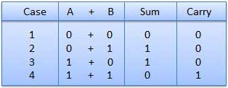

For example, we can add the quantities 1012 and 1112 as follows:

carry 1 1 1

1 0 1

+ 1 1 1

1 1 0 0

1. The subtraction of binary numbers follows the same rules as the subtraction of numbers in the decimal number system. The only variation is one borrows a group of 2 in the binary system.

For example, we can subtract the quantity 1012 from 10102 as follows:

borrow 2 2

~~1~~ ~~0~~ ~~1~~ ~~0~~

- 1 0 1

1 0 1

1. Similarly, we can make use of the following table when performing addition in the octal number system:

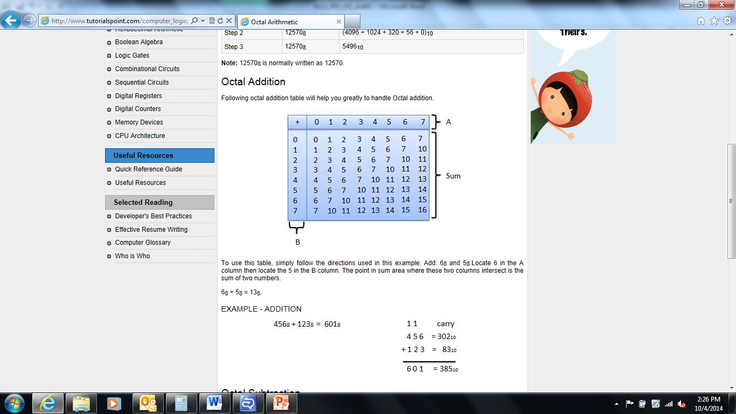

Using this table, 68 (represented by A) + 78 (represented by B) = 158

Thus, we can add the quantities 268 and 178 as follows:

carry 1

2 6

+ 1 7

4 5

1. The subtraction of octal numbers follows the same rules as the subtraction of numbers in the decimal number system. The only variation is one borrows a group of 8 in the octal system.

For example, we can subtract the quantity 168 from 318 as follows:

borrow 2 9

~~3~~ ~~1~~

- 1 6

1 3

1. We can also make use of the following table when performing addition in the hexadecimal number system:

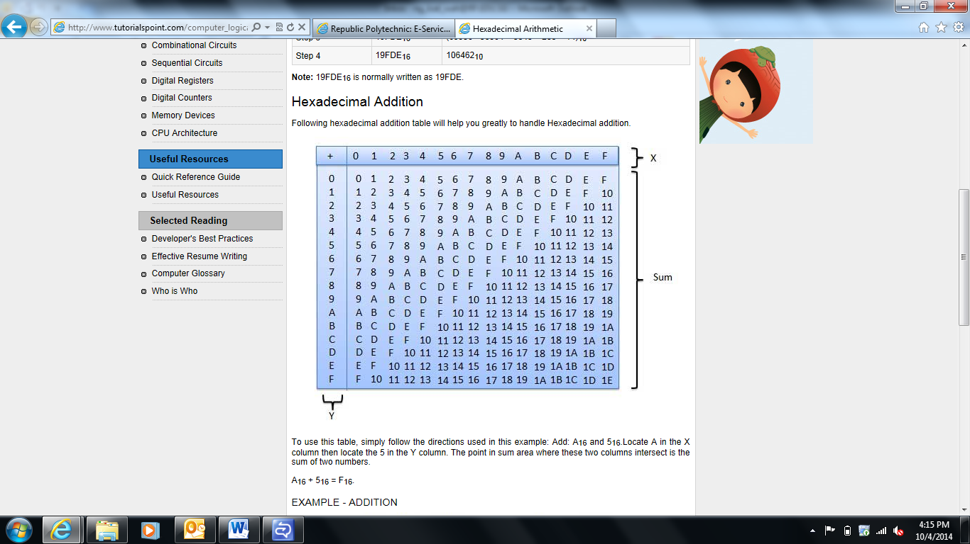

Using this table, E16 (represented by X) + A16 (represented by Y) = 1816

Thus, we can add the quantities 2E16 and 1A16 as follows:

carry 1

2 E

+ 1 A

4 8

1. Similarly, the subtraction of hexadecimal numbers follows the same rules as the subtraction of numbers in the decimal number system. The only variation is one borrows a group of 16 in the hexadecimal system.

For example, we can subtract the quantity 2A16 from 6216 as follows:

borrow 5 18

~~6~~ ~~2~~

- 2 A

3 8

**Putting it together**

1. A broken stone tablet (with the inscription “WMM”) was excavated as shown in Figure 2 below.

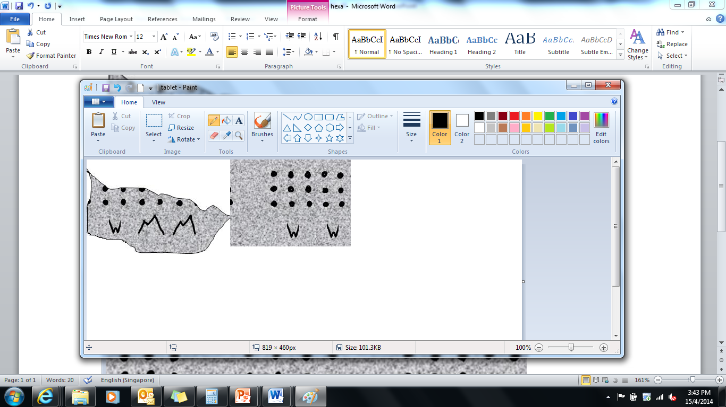  
Figure 2

* 1. How many dots would you expect to see on this stone tablet if it is intact, i.e. unbroken? Explain how you arrived at your answer.
  2. Suppose the scientists found another stone tablet with the inscription “AW”. Determine the total number of dots you would expect to see on both stone tablets. Explain how you arrived at your answer.
  3. What are the symbols, representing the answer that you expect to see if “AW” was subtracted from “WMM”? Explain how you arrived at your answer.

|  |
| --- |
| ***Practice Questions***  *(It is essential to complete these practice questions so that you can understand the concepts of this lesson better and be more confident and competent in handling related questions.)*  Conversion from other base system to decimal  Convert the binary (base 2) number 1000 01112 to its decimal number form.  Convert the base 4 number 13024 to its decimal number form.  Convert the base 6 number 2536 to its decimal number form.  Convert the octal (base 8) number 658 to its decimal number form.  Convert the hexadecimal (base 16) number E0216 to its decimal number form.  Conversion from decimal to other base system  Convert the decimal number 53 to its binary (base 2) number form.  Convert the decimal number 89 to its base 4 number form.  Convert the decimal number 107 to its base 6 number form.  Convert the decimal number 123 to its octal (base 8) number form.  Convert the decimal number 154 to its hexadecimal (base 16) number form.  Conversion between other base systems  Convert the binary (base 2) number 11 0012 to its octal (base 8) number form.  Convert the binary (base 2) number 1101 0101 01102 to its hexadecimal (base 16) number form.  Convert the octal (base 8) number 2078 to its binary (base 2) number form.  Convert the hexadecimal (base 16) number B516 to its binary (base 2) number form.  Addition/Subtraction  [You may want to watch the following [video](https://drive.google.com/file/d/0Bzod2ecBsQw1Vk1nYzhQdkRnSms/view?usp=sharing) which would help to recap some of the key concepts learnt before attempting the following question.]   1. Determine the following using the same number base: 2. 1001 10102 + 1101 0101 01102 + 1 00102 3. 2034 + 13024 4. 1568 + 2318 5. 9A16 + D5616 + 1216 6. Determine the following using base 8: 7. 2134 + 658 8. 5168 + AC16 9. Determine the following using the same number base: 10. 100102 – 10112 11. 13024 – 2034 12. 2318 – 568 + 158 13. D5616 – 9A16 14. Determine the following using base 2: 15. 3224 – 11012 16. 6C16 – 568 |

**Exploring Further…**

1. Now that we have learnt how to convert numbers as well as performing addition and subtraction in different bases, it would be interesting to find out how we can perform multiplication in different bases. What is the product of 1012 and 112? Explain how you arrived at your answers.